TERMWORK 4.2

NAME-PARISHKAR SINGH

USN – 2GI20CS081

DIV – B

* 1. The class Cylinder inherits all the instance variables (radius and color) and methods (getRadius(), getArea(), among others) from its superclass Circle. It further defines a variable called height, three methods getHeight(), setHeight() and getVolume() and its own constructors. Implement the hierarchy as shown below:

*package* practice;  
*import* java.util.Scanner;  
*class* Circle{  
 String color;  
 *double* radius;  
 *public* Circle() {  
 radius = 1.0;  
 color = "red";  
 }  
 *public* Circle(*double* radius) {  
 *this*.radius = radius;  
 }  
 *public* Circle(*double* radius,String color) {  
 *this*.radius = radius;  
 *this*.color = color;  
 }  
 *public double* getRadius() {  
 *return this*.radius;  
 }  
 *public void* setRadius(*double* radius) {  
 *this*.radius = radius;  
 }  
 *public void* setColor(String color) {  
 *this*.color = color;  
 }  
 *public* String getColor() {  
 *return* color;  
 }  
 *public double* getArea() {  
 *return* Math.PI*radius*radius;  
 }  
}  
*class* Cylinder *extends* Circle {  
 *double* height;  
 *public* Cylinder() {  
 *super*();  
 height = 1.0;  
 }  
 *public* Cylinder(*double* height) {  
 *super*();  
 *this*.height = height;  
 }  
 *public* Cylinder(*double* height,*double* radius) {  
 *super*(radius);  
 *this*.height = height;  
 }  
 *public* Cylinder(*double* height,*double* radius,String color) {  
 *super*(radius,color);  
 *this*.height = height;  
 }  
 *public double* getHeight() {  
 *return this*.height;  
 }  
 *public void* setHeight(*double* height) {  
 *this*.height = height;  
 }  
 *public double* getVolume() {  
 *return super*.getArea()*height;  
 }  
}  
*public class* Four {  
 *public static void* main(String[] args) {  
 Circle c1 = *new* Circle();  
 System.out.println("Radius of circle : "+c1.getRadius());  
 System.out.println("Color of the circle : "+c1.getColor());  
 c1.setColor("green");  
 c1.setRadius(2.31);  
 System.out.println("Radius of circle : "+c1.getRadius());  
 System.out.println("Color of the circle : "+c1.getColor());  
 System.out.printf("Area of the circle : %.3f\n",c1.getArea());  
 System.out.println("");  
 Cylinder c2 = *new* Cylinder(3.0,1.0,"violet");  
 System.out.println("Radius of cylinder : "+c2.getRadius());  
 System.out.println("Height of cylinder : "+c2.getHeight());  
 System.out.printf("Volume of cylinder : %.3f\n",c2.getVolume());  
 System.out.println("Color of the cylinder : "+c2.getColor());  
 }  
}

Output:  
 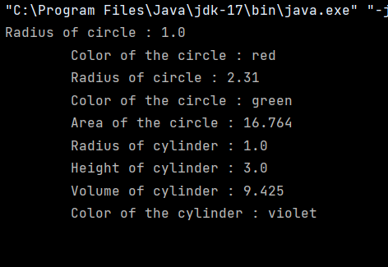TERMWORK 4.3

NAME-PARISHKAR SINGH

USN – 2GI20CS081

DIV – B

* 1. Implement a BANK class to demonstrate the inheritance in Java by implementing get Rate Of Interest member function for three different banks, as shown below.

*import* java.util.*;  
*class* Bank  
{  
 *protected* String name;  
 *protected double* balance;  
 *protected int* accountNumber;  
 *protected float* inamt;  
 Bank( String name,*double* balance, *int* accountNumber , *float* inamt)  
 {  
 *this*.balance=balance;  
 *this*.name=name;  
 *this*.accountNumber=accountNumber;  
 *this*.inamt=inamt;  
 }  
 *void* disp()  
 {  
 System.out.println("Account holder:"+name+"\nAccount number:"+accountNumber);  
 System.out.println("Balance:"+balance);  
 }  
  
}  
*interface* interest  
{  
 *float* getRateofInterest(*int* t);  
}  
*class* SBI *extends* Bank *implements* interest  
{  
 SBI(String name,*double* balance, *int* accountNumber , *float* r)  
 {  
 *super*(name,balance,accountNumber ,r);  
 }  
 *public float* getRateofInterest(*int* t)  
 {  
 *return* (*float*)(inamt/(balance*t)*100);  
 }  
}  
*class* icici *extends* Bank *implements* interest  
{  
 icici(String name,*double* balance, *int* accountNumber ,*float* inamt)  
 {  
 *super*(name,balance,accountNumber ,inamt);  
 }  
 *public float* getRateofInterest(*int* t)  
 {  
 *return* (*float*)(inamt/(balance*t)*100);  
 }  
}  
*class* Axis *extends* Bank *implements* interest  
{  
 Axis(String name,*double* balance, *int* accountNumber , *float* inamt)  
 {  
 *super*(name,balance,accountNumber ,inamt);  
 }  
 *public float* getRateofInterest(*int* t)  
 {  
 *return* (*float*)(inamt/(balance*t)*100);  
 }  
}  
*class* Main  
{  
 *public static void* main(String args[])  
 {  
 SBI s=*new* SBI("parishkar",45100,123,2500);  
 s.disp();  
 System.out.println("Rate of interst is "+s.getRateofInterest(3)+"%\n");  
 Axis a=*new* Axis("adam",28000,12,1500);  
 a.disp();  
 System.out.println("Rate of interst is "+a.getRateofInterest(2)+"%\n");  
 icici i=*new* icici("eve",29000,24,1800);  
 i.disp();  
 System.out.println("Rate of interst is "+i.getRateofInterest(5)+"%\n");  
 }  
}

OUTPUT

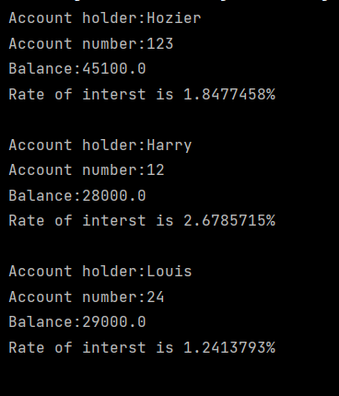

TERMWORK 5B.1

NAME-PARISHKAR SINGH

USN – 2GI20CS081

DIV – B

5b.3) Design a base class where Hospital provides no. of patients admitted in it. Number of patients varies with the different hospitals, For example Health India hospital has 1657 patients, IVY hospital has 2965 patients  and Apollo Hospital has 1631 patients. Hospital parent class which has one method getNumberOfPatients() and sub class HealthIndia, IVY and Apolo class which extends parent class & override its method.

*class* Hospital {  
 *protected int* nop;  
  
 Hospital(*int* nop) {  
 *this*.nop = nop;  
 }  
  
 *int* getNumberofPatients() {  
 *return* nop;  
 }  
}  
  
*class* HealthIndia *extends* Hospital {  
 HealthIndia(*int* nop) {  
 *super*(nop);  
 }  
  
 *int* getNumberofPatients() {  
 *return* nop;  
 }  
}  
  
*class* IVY *extends* Hospital {  
 IVY(*int* nop) {  
 *super*(nop);  
 }  
  
 *int* getNumberofPatients() {  
 *return* nop;  
 }  
}  
  
*class* Apollo *extends* Hospital {  
 Apollo(*int* nop) {  
 *super*(nop);  
 }  
  
 *int* getNumberofPatients() {  
 *return* nop;  
 }  
}  
  
*class* Main {  
 *public static void* main(String args[]) {  
 HealthIndia h = *new* HealthIndia(1657);  
 System.out.println("Number of patients in HealthIndia is " + h.getNumberofPatients());  
  
 IVY i = *new* IVY(2965);  
 System.out.println("Number of patients in IVY is " + i.getNumberofPatients());  
  
 Apollo a = *new* Apollo(1631);  
 System.out.println("Number of patients in Apollo is " + a.getNumberofPatients());  
 }  
}

OUTPUT:

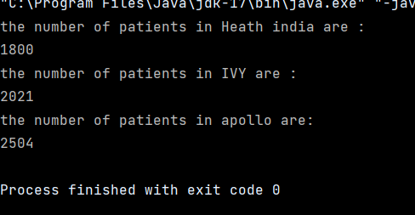

TERMWORK 5B.2

NAME-PARISHKAR SINGH

USN – 2GI20CS081

DIV – B

5 b. 2) Design a base class ArrayStack that uses array to hold the elements and has 3 methods namely, push, pop and display. Derive a class LinkedStack that overrides these 3 methods and uses linked list to implement stack. Demonstrate the working of both the classes by performing push, pop and display operations on the objects of the above to classes.

*import* java.io.*;  
*import* java.lang.*;  
*import* java.util.*;  
*class* ArrayStack{  
 *int* top,size;  
 *int* stack[];  
 ArrayStack(*int* s){  
 top=-1;  
 size=s;  
 stack=*new int*[size];  
 }  
 *void* push(*int* item){  
 *if*(top==size-1){  
 System.out.println("Stack Overflow!");  
 *return*;  
 }  
 stack[++top]=item;  
 System.out.println("Item Added : "+item);  
 }  
 *void* pop(){  
 *if*(top==-1){  
 System.out.println("Stack Underflow!");  
 *return*;  
 }  
 System.out.println("Item popped : "+stack[top--]);  
 }  
 *void* display(){  
 *if*(top==-1){  
 System.out.println("Stack Empty!");  
 *return*;  
 }  
 System.out.println("Stack items");  
 *for*(*int* i=top;i>=0;i--){  
 System.out.println("|"+stack[i]+"|");  
 }  
 System.out.println("|--|");  
 }  
}  
  
*class* LinkedStack{  
  
 *private class* Node{  
 *int* data; *// holds data* Node link; *// reference variable Node Type* }   
 Node top; *// Head Node* LinkedStack(){  
 *this*.top=*null*;  
 }  
 *void* push(*int* item){  
 Node temp = *new* Node();  
 temp.data = item;  
 temp.link = top;  
 top = temp;

System.out.println("Item Pushed : "+item);  
 }  
 *void* pop(){  
 *if*(top==*null*){  
 System.out.printf("\nStack Underflow");  
 *return*;  
 }  
 System.out.println("Item popped : "+top.data);  
 top = (top).link;  
 }  
 *void* display(){  
 *if*(top==*null*){  
 System.out.printf("\nStack Underflow");  
 *return*;  
 }  
 Node temp=top;  
 *while*(temp!=*null*){  
 System.out.println("|"+temp.data+"|");  
 temp = temp.link;  
 }  
 System.out.println("|--|");  
 }  
}  
  
*class* TW5_B{  
 *public static void* main(String[]args){  
 ArrayStack s = *new* ArrayStack(10);  
 System.out.println(" -- Array Stack --");  
 s.push(10);  
 s.push(14);  
 s.push(13);  
 s.push(74);  
 s.push(51);  
 s.display();  
 s.pop();  
 s.pop();  
 s.display();  
 LinkedStack c = *new* LinkedStack();  
 System.out.println(" -- Linked Stack --");  
 c.push(11);  
 c.push(21);  
 c.push(11);  
 c.push(74);  
 c.push(15);  
 c.display();  
 c.pop();  
 c.pop();  
 c.display();  
 }  
}

Output: -- Array Stack --

